**KNUCKLES, THE ASSISTIVE ROBOTIC ARM**

*Project featured at the 2019 ECEDHA Annual Conference*

*Sponsored by IEEE UH Makers*

Andrew Blanchard (Team Leader), Matthew van Zuilekom,   
Paola Hernandez, Rym Benchaabane

Department of Electrical and Computer Engineering

University of Houston

Houston, TX 77204-4005

**Abstract**

A stationary 3D-printed voice-activated robotic arm that can retrieve objects and give them to a user upon request. This project is designed with the intent to help the elderly and lab researchers. Controlled by the Robot Operating System (ROS), the arm has five degrees of freedom and a two finger gripper. The two types of input sensors are a multi-directional microphone and a camera. The Intel Speech Enabling Developer Kit microphone is connected to a Raspberry Pi3+ and Alexa Voice Service. The RealSense camera detects AprilTags, a form of QR code. To request an object, the user needs to say: "Alexa trigger Knuckles to give me the bottle".

**Introduction**

Knuckles is a 3D printed assistive robotic arm that will hand the user requested objects and tools through voice commands. It will serve as a convenient assistant that will increase the user’s productivity and decrease the risk of dexterity incidents. The problem is that multitasking causes a lack of focus on a task which results to a waste time, money, and can also lead to serious injury. What is needed is a solution that allows the user to continue with their task without distractions, and can assist the user as needed. The extra hand will allow one to focus on the work without having to get up and grab another tool, which saves one time and effort in completing the current task.

**Figure 1. Overview diagram of Knuckles functionalities**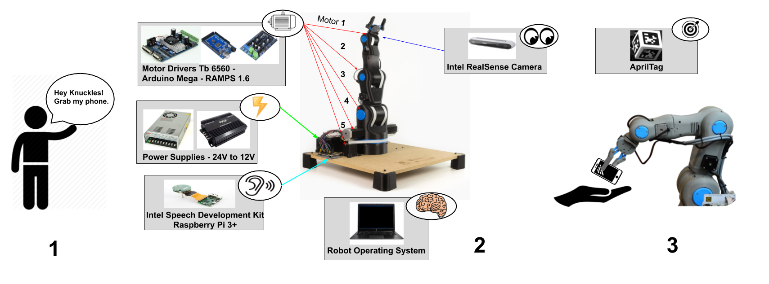

**Design Considerations**

Knuckles is a 3D printed robotic arm that has five degrees of freedom. We were planning to use a 3D object detection program using the depth camera on Intel RealSense Camera and a point cloud. However, due to time constraints, we implemented AprilTag detection. AprilTags stored the object position in the received image, distance from the camera. For voice recognition, we used the Intel Speech Enabling Developer Kit as our multi-directional microphone. To process speech to text, we connected the microphone to the Raspberry Pi3+ and Alexa Voice Service. Therefore, internet connection is required. Knuckles is able to recognize and pick up 9 objects and understand a total of 64 commands. Knuckles completes a full sequence in less than 7 seconds. A Graphical User Interface was developed to make our project more user friendly. All of these mentioned modules are interconnected thanks to Robot Operating System (ROS). Pertaining the power system, every hardware device working with the motors require at least 12V and Knuckles can be plugged-in in mains.

**Design Constraints**

Our main design constraint is the time allotted to develop a gripper that’s capable of grabbing a larger range of objects. In addition, due to the strength of our motors, we are only able to lift a restricted weight of 0.5 kg. Besides, Knuckles is a stationary robot and has a maximum reach of 0.5 m. This limited reach can be overcome by making Knuckles non-stationary. The fact that Knuckles is 3D-printed makes the robot delicate and heavy as well.

**Conclusions and Future Work**

This project was a proof of concept and a learning curve for the entire team. We covered new topics such as robotics and Linux. Knuckles can be upgraded with the implementation of an object detection program (can recognize any object, not dependent on AprilTag detection). This work can be extended by making Knuckles able to turn towards the user to provide the object using the multi-directional microphone. In addition, Knuckles can be placed on a mobile base so he can move around his environment, and better assist the user. Lastly, the two-finger gripper should be replaced with three-finger gripper design, allowing Knuckles to properly grab cylindrical objects.

**Acknowledgements**

This project would have not been possible without our sponsors IEEE UH Makers and Dr. Aaron Becker. Our entire team would to thank them for their valuable contributions and undivided advice.